PROJECT REPORT ON

GOVERNMENT ARTS AND SCIENCE COLLEGE

SUBMITTED BY,

RANJANI

SOWMIYA

SOUNTHARYA

NITHYA SRI

I REVOLUTION:A DATA –DRIVEN EXPLORATION OF APPLE’S IPHONE IMPACT IN INDIA.

INTRODUCTION:

* 1. PROJECT ARE VIEW:

Apple Inc. has improved its iphone on multiple fronts including a slick hardware design faster processor better resolution improved camera modulus.

PURPOSE:

The iphone is a smartphone made by apple that combines a computer ipod digital camera and cellular phone into one device with a tochscrren interface.

2.PROBLEM STATEMENT:

The overall proplem at apple Inc is a stagnant iphone growth problem innovation and maretting efforts.

2.1 EMPATHY MAP:

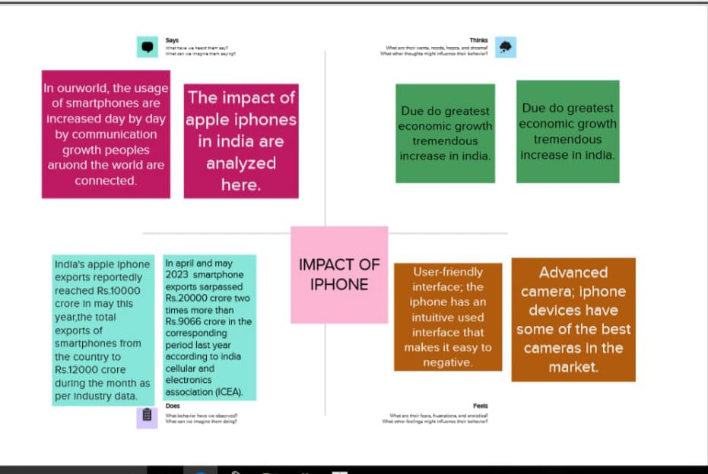

2.2 IDEATION AND BRAINSTORM MAP:

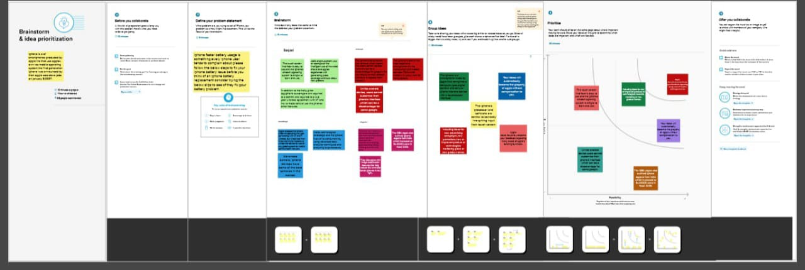

3.RESULT:

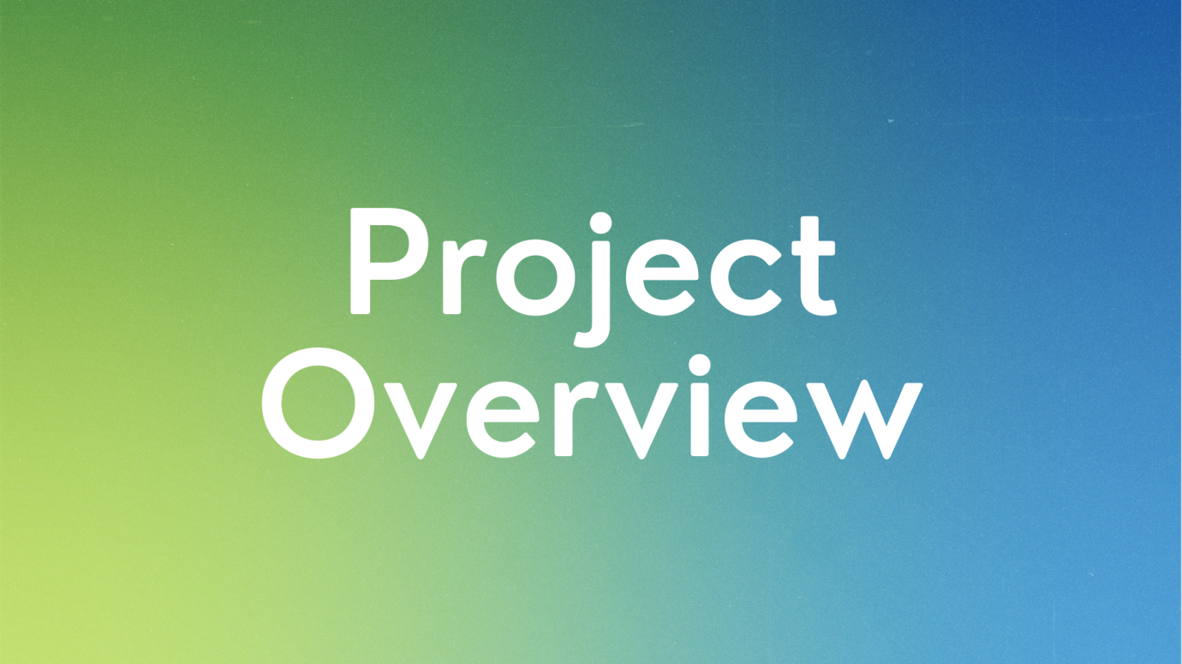

4.ADVANTAGE AND DISADVANDAGE:

User –friendly interface .the iphone has an intuitive user interface that makes it easy to navigate.

High-quality display:the iphones retina display is one of the best cameras in the market.

5.APPLICATION:

A software application that runs under ios which is the operating system that powers apples mobile devices.

In most cases any application that runs on an iphone also runs on an ipad and touch.

Howere apps designed strictty for ipads which have larger scrrens do not work on iphones and ipods.

6.CONCLUSION:

In summary it is apparent the iphone was and still a rememmaral invention of technological advancement.

Its revolutionary technology has led to the variety of smartphones that are in use today.